How to apply IA Technics in Game Development
[1]Diego Tubino Gomes Hartmann, [2]Philipp Altendorf
Escola de Artes, Comunicação e Hospitalidade

Design de Jogos e Entretenimento Digital – Univali – SC– Brazil
[1]dtghartmann@edu.univali.br, [2]philipp.altendorf@edu.univali.br

1. Introduction
The history of humanity and games go hand in hand, going back to our origins themselves. To this day, people seek fun and pleasure in many different activities that can be called games (Huizinga, 1949).
People seek fun and pleasure in many different activities that can be called games (Huizinga, 1949), that can be defined as can be defined as a voluntary activity carried out within certain limits of time and space, according to freely agreed, but mandatory rules, endowed in itself (Huizinga, 1971).
They include simple playful activities such as hide and seek, complex board games such as Go (500 BC), card games, athletic games, and with the advancement of modern technology, video games (1950)→is it a reference? are becoming more popular. Although they seem very different, they have similarities that are the basic common elements of games.
A game can be described, also, as a structured system in which the participant or so-called player accepts a predetermined set of rules that apply only in this artificially created space in order to achieve a certain goal. Depending on the game, these rules or game mechanics interact in a complex manner. Crawford (1982) describes one of these common elements as representation.
Games are often played with other people, and this interaction creates an emotional dynamic that is attractive to many players and distinguishes games from other static media or activities. Playing against a human opponent provides a new interpersonal challenge to solve each time. Interaction is the second element of games. To prevent the player from immediately reaching the goal and thus winning, the game needs conflict. This conflict arises from the interaction with another player or obstacles, which can be direct or indirect. The last characteristic described by Crawford (1982) is safety. The game must provide a safe space in which the player can accept a challenge and try different approaches to emerge from the conflict victorious or defeated but without consequences.
However, representation, interaction, conflict and security alone do not make a game. Like anything else created by humans, it needs order and planning to make sense.
However, representation, interaction, conflict and security alone do not make a game; it needs order and planning to make sense, and that is the reason why Design is essential: it leads to a coherent product. Design is the act of planning objectively to give a product its logical structure and therefore its form depending on the needs to function (Munari, 1966). Game Design, then, is the task of creating an experience that meets the expectations of the player. Since a meaningful experience cannot be delivered directly, the game designer must create a set of game mechanics that guide the player through the game and ultimately make the experience possible (Schell, 2015).
As mentioned earlier, one characteristic of games is interaction. When it comes to digital games, players do not necessarily interact with other humans, especially at the beginning of the video game era when multiplayer games were not so common. Therefore, the implementation of Artificial Intelligence (AI) systems is fundamental to video game development. AI is the area of ​​computing that consists of making machines simulate the human way of thinking in order to learn and solve problems (Reads, 2017). The classical academic view describes AI as a multidisciplinary field with the goal of building intelligent entities.
These autonomous and adaptive systems analyze their environment and make decisions based on it. Game AI, however, has a different goal and is not concerned with creating true intelligence. All the different parts that make up a video game, such as graphics, sound, gameplay, and game AI, serve only the main goal of creating a special experience for the player. Therefore, game AI is only about creating the illusion of intelligence, with the intention to maximize the player's enjoyment and participation during long periods of gambling (Mass and Luc, 2019).
With the increased complexity of modern video games and the high expectations of players, the design and implementation of artificial intelligence systems is still a challenge. Several AI methods already exist that are used to solve specific problems in video games. Game designers therefore need to understand how they work in order to use them in the best possible way. In this paper, the most common AI methods used in video games for movement and decision making will be explained and their practical application will be demonstrated with a game.
Furthermore, the article describes the relation of Artificial Intelligence and Digital Games (2), what movement techniques exist for Games (2.1) and popular decision-making techniques (2.2) used by Game AI. The article continues with the proposal of AI methods for a game (3), the development (4) and shows the results (6).

2. Artificial Intelligence and Digital Games
Because AI encompasses many different disciplines and technologies, it is constantly being redefined as new topics are introduced, and others are classified as non-AI, there is no precise definition of AI. However, AI systems can be described by their characteristics, which primarily relate to natural language processing, knowledge representation, automated reasoning, machine learning, computer vision, and robotics (Russel and Norvig, 2010).
To successfully process these massive streams of data, AI systems rely on logic, computation, and probability. Algorithms are limited by what is computable, and thus their functionality to produce unambiguous results. Because of the non-computable inputs, algorithms can run endlessly in a loop. Machine learning, deep learning, data science, and robotics are subfields of or related to AI and are influencing the development of AI science.
The development of self-driving cars requires a combination of AI techniques from different fields. Search algorithms must navigate through complex environments and analyze different ways to solve the problem. Depending on time, cost, effort, or other criteria, different search techniques lead to different solutions. In a constantly changing and dynamic environment, decisions must be made quickly and lead to the desired consequences. Computer Vison collects data around the moving vehicle to detect obstacles. All systems must work with high precision and reliability to avoid accidents.
Among the areas in which AI is applied - such as Image Recognition (Google and IBM), Speech Recognition (Siri and Alexa) and Translation (GNMT) - IT Automation is where AI is most widespread, at 47% of companies; followed by Quality Control, with 46%, and Cybersecurity, with 41% (Deloitte, 2018). When using AI systems in games, the purpose is to give the appearance of intelligent behavior. The best AI system is the one that provides the best player experience. Players often interact with AI systems through non-player characters (NPC), an autonomous agent capable of making decisions. The AI communicates with the player through animation and audio what their intentions, opinions, or feelings are (Rabin, 2013).
One of the first games to feature an AI system was Pac-Man. NPCs (enemy ghosts who follow Pac-Man) seem to consciously conspire against the player, being moved by the AI ​​technique called the State Machine (Millington and Funge, 2009). The State Machine consists of a predefined state for - in the case of a game - the NPC, establishing actions (such as, Stopped, Walking and Shooting) that are triggered under certain conditions. For better understanding, Figure 1 illustrates a Lamp State Machine, which has two states: On and Off, which are changed according to the established conditions.

Figure 1. Lamp state machine
Next, Figure 2 illustrates a State Machine from one of Pac-Man's NPCs, with the Scatter, Hunt and Flee states.
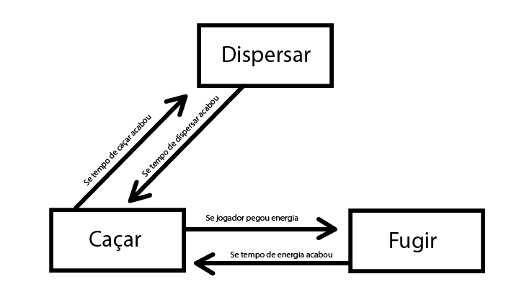
Figure 2. Pac-Man NPC’s state machine.

The first-person shooter (FPS) F.E.A.R, released by Monolith Productions in 2005, used communication through audio to create a believable AI system that was new to the gaming industry in this way. The usual gameplay behavior in first-person shooters is based on animations and superficial comments, for example, the player fires at an enemy and the enemy responds with a painful animation and grumbling. When multiple enemies are in combat with the player, it becomes more obvious that they are talking to themselves. Each AI acts individually and says phrases like "Where is he?", "I'm hit!", "I can't see him.". The AI's responses seem out of context or don't explain the situation to the player.
The AI in F.E.A.R. uses a dialogue system to explain mental state or intentions to the player. One enemy may yell "What's your status?" and another may reply "I'm hit" or "I'm fine!". This system successfully communicates to the player that they have hit and injured an enemy and, more importantly, creates the illusion of human-like teamwork. The effective use of language fools the player into thinking that the AI is communicating, thinking, planning, and coordinating attacks against the player (Rabin, 2015).

2.2 Movement techniques for Games
Moving agents in games involves finding paths form one point to another through a (complex) digital world space. Game AI uses pathfinding techniques to find the shortest or quickest route from point A to point B respecting time and distance constraints. One of the first solutions was the Dijkstra algorithm from 1959. Even though pathfinding algorithms have improved over time, complex 3D environments are still a challenge for pathfinding algorithms to find not only the shortest path, but the best path.
In order that the Game can use pathfinding solutions, the game level must be represented in a readable data structure. In a graph, the essential structure of the problem is represented, freed from insignificant side aspects. Figure 3 shows a general graph made of nodes (circles) and connections (lines).
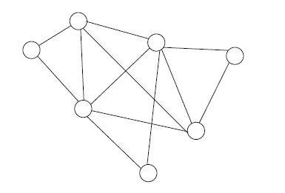
Figure 3. A general graph
In game application nodes represents a certain aera, such as a room, hallway, or a defined outdoor space. Connections show the relations between the areas. These connections dictated how to go from node X to node Y. A commonly used type of graph for pathfinding algorithms is called the directed non-negative weighted graph, see Figure 4.
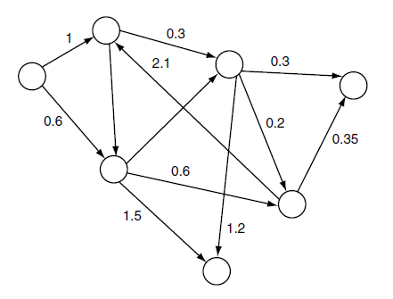
Figure 4. directed non-negative weighted graph
The numerical value represents the weight or cost, in games mostly related to time or distance. Each connection has only one possible direction, indicated by the arrowhead. In a game this would be represented through obstacles or level changes which does not allow to go the same path back. In order that pathfinding algorithms can provide solutions they need access to nodes, connections and their corresponding cost and direction (Millington and Funge, 2009).
The performance of a pathfinding algorithm is based on its pathfinding list, the graph, and the heuristic. The heuristic evaluates the cost of the optimal path from node A to node B. Each heuristic is more suited to a specific problem and can reduce costs and time. Straight-line (Euclidean) distance, octile distance, which only allows 45° and 90° angles and Manhattan (city-block) distance must be chosen depending on the given problem (Rabin, 2013).
For game designers, it is important not only to create an interesting opponent, but also a predictable one. A guard will always follow its designed path and the player is rewarded for observing the pattern and identifying the enemy’s weakness. Complex enemy movement can be frustrating for players in certain situations. In this cases Waypoints help the designers to create a more pleasing experience. A waypoint is a single position (node) in the virtual game world. Each node is placed in the line of sight of the other node so that a game-controlled character always can reach the next node by using a simple line-of-sight algorithm. Figure 5. Shows a map with connected nodes that build the pre-computed path.
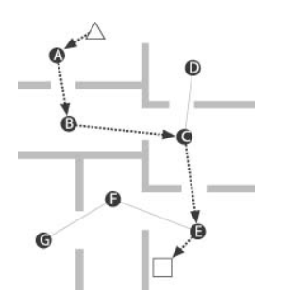
Figure 5. Waypoint based path

These waypoints can also mark a fixed safe location or positions with tactical features. When the player engages with the enemy, he will move to the closest waypoint to have a strategic benefit. The player will perceive this as intelligent behavior (Bourg and Seeman, 2004).
Most games use an algorithm called A* that calculates a suitable route through the game level so that a character can move to its goal as sensible and rapid as possible. Pathfinding sits in between the movement AI system and decision-making AI system, shown in Figure 6.
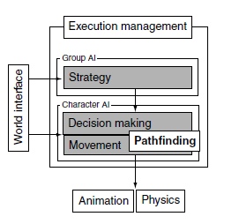
Figure 6. AI model
The movement AI system is responsible for calculating how the character can move in the Game and the decision-making AI dictates the where to go. A* is a point-to-point pathfinding algorithm which is simple to implement, efficient and offers room for optimization (Millington and Funge, 2009). A* chooses the path with the, through a heuristic established, most likely shortest path instead of the lowest cost path. If the quality of the heuristic is accurate, A* performs well.
When characters, animals or other entities must move in cohesive groups rather than independently, steering behaviors are used to simulate a more believable movement. The flocking algorithms presented by Craig Reynolds (1987) introduced a coordinated group movement with the illusion that all individual members have the same purpose. This behavior is achieved through matching the position of the unit with the average position of the target. The unit is aligned to match the orientation of the target and separation behavior avoids collisions with other units (Bourg and Seemann, 2004).

2.2 Decision-making techniques for Games
Besides Movement techniques another big field of AI in Games are decision-making techniques. An entity analyzes a data set to execute a desired action. The information needed to generate this action can come from internal and external knowledge. External knowledge provides the AI with information about the game environment around it like the geometry of the level, position of other game characters or changing states in the environment. The internal knowledge is about the internal state or thought process of the character which includes, its health, objectives and performed actions in the past. Based on this knowledge the AI decides what to do what is represented by internal or external changes. What the player perceives are mostly external changes. This process is shown in Figure 7 (Millington and Funge, 2009).
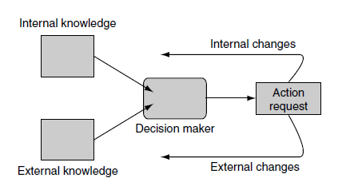
Figure 7. Decision making schematic
To create more believable character behaviors that don´t just switch between two distinct states or so-called classical sets e.g. confident or cautious, game developers use Fuzzy Logic to create a gradation in states. Fuzzy Logic adds values to the sets so that a character can be confident with a value of 0.4. The sets are called fuzzy sets and the value is the degree of membership. When something is completely in the fuzzy set the degree of membership receives a value of 1.
Something completely outside the fuzzy set on the other hand receives a value o 0. In traditional logic a character can`t be healthy and hurt at the same time because these sets are mutually exclusive. However, this is possible with Fuzzy Logic, through the different degrees of membership for each set. A character can be 0.2 hurt and 0.8 healthy. But it is necessary that the membership degrees sum to 1. An invalid set would be 0.5 hurt and 0.7 healthy. This technique creates more a believable game character behavior since also humans show a large spectrum of in between states in their behavior (Millington and Funge, 2009).
Another approach to AI behaviors is the implementation of machine learning techniques. One of the oldest and widely used are Neural Networks. There are many types of neural networks but the most common used in games are multilayer perceptrons (MLPs). These MLPs are typically made of three layers of nodes. These layers are the input layer, the hidden layer, and the output layer. Each of these nodes is connect and communicates with a layer of nodes before and after. The flow of information in only in one direction, starting form in input to the hidden layer and then to the output. This pattern is the so call topology of the neural network. Every node also has a value, the weight, associated, in a range from zero to one. Figure 8 shows a multilayer perceptron network.
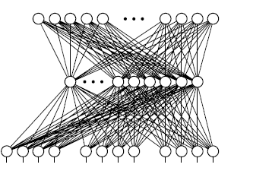
Figure 8. Multilayer perceptrons (MLPs)
The behavior of an MLP is dictated by the value of its weights and the process of training. The training involves many iterating and the performance is based on the quantity of nodes. Through the training the AI should learn how to respond to a given situation based on the input values. This saves lot of programming time and tweaking of the right values for each situation. But for every change needed in the AI behavior the training process must start over again. Neural Networks have as all tools strengths and weaknesses. MLPs are useful for games with well-defined set of actions or response which don´t require a lot of control through the designers (Millington and Funge, 2009).
Genetic Algorithms belong also in the group learning techniques inspired by nature. They start with a set of solutions, choose the best ones, and evolve them to find an optimal solution for the given problem. Much like the Darwinian principle, survival of the fittest. The algorithm is divided into 5 steps and starts of by randomly generated states, the so-called population creation. This pool of possible solutions gets evaluated in the fitness function.
The more suitable the solution, the higher the score. In the selection phase the two highest scored solutions are chosen for to create the next generation. These act as parents to generate offspring which will naturally inherit the strongest features. The other solutions are dropped. The crossover stage creates the new generation based selected parents. Through random mutation more possible solutions are created. The new population is then used in the next iteration of the algorithm. This evolution process can be time consuming to and does not guarantee an optimal solution (Russel and Norvig, 2010).
Game Engines like Unity or Unreal Engine provide the game developer with a popular AI tool named Behavior Trees. Through their graphical user interface (GUI) they can be used by developers form different areas. Figure 9 shows a behavior tree example in Unreal Engine 4.
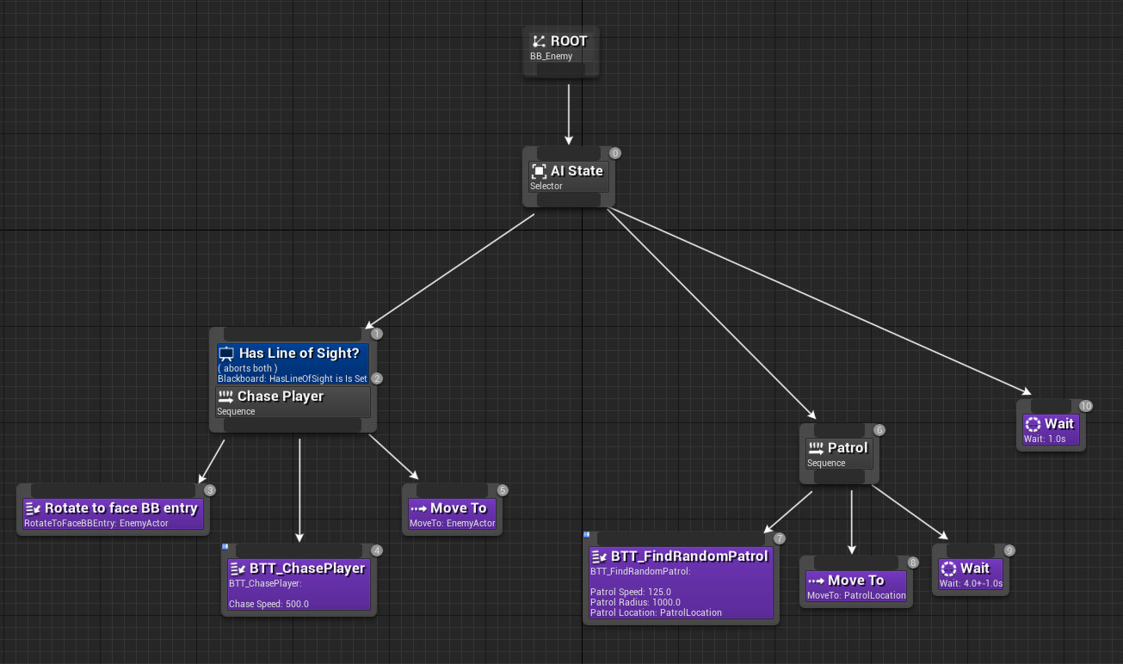
Figure 9. GUI of a Behavior Tree in Unreal Engine 4
Behavior Trees seem like State Machines, but their core function is built on executing tasks. Task ware divided in Conditions, Actions and Composites. Each task can have a sub-tree and this composability creates complex character behaviors which is one of the reasons that behavior trees are frequently used in modern games. The Condition tasks evaluates properties of the game, like the position of character or gameplay elements or the state of objects and characters.
Each task has a limited CPU time to executed and then they return a Boolean value, success, or failure. Based on this evaluation the task executes actions which can be for animations, play audio or change the internal state of the character. Composite tasks run child behavior and decide depending on the children’s return code whether to stop or continue executing the task.
Two types of Composite tasks are used in game development. The selector returns immediately a success status code when on of its children runs successfully. In case the children are failing, it will keep trying. Just when there are no children available, it will return a failure code. The Sequence returns immediately a failure status code when one of its children fails. When the children are succeeding it will go on and when there are no children available it returns a success code.

3. Artificial Intelligence Proposal
To further illustrate this, a 3D top-down game is designed in Unity to demonstrate some of the AI methods mentioned in a practical application. The game consists of the player, his companions and enemy drones. The player must free his companions, who are being held captive and guarded by patrolling drones.
The player can start the game via the menu. The player controls his avatar with the W, A, S, D keys on the keyboard. The drone's behaviour is controlled by AI methods so that it patrols a predetermined path and follows the player on sight. At medium range, the drone starts shooting at the player. At short range, the drone enters rapid-fire mode. If the drone loses visual contact with the player, the drone stops for 3 seconds before resuming its patrolling behaviour. Each hit reduces the player's health bar; or does he have 3 lives? The player's goal is to free all his companions and he loses if he has no more lives. The companions follow the player when he enters the rescue zone. The player returns to the menu after winning or losing.
The game uses a state machine, A* and a flocking algorithm to demonstrate the application of AI methods in games. The movement of the patrolling drone is controlled by a path-moving technique. In Unity, this is done with waypoints. The movement of the patrolling is automatic and is done with waypoints. The drone always moves from one waypoint to the next, according to the waypoints’ index inside their array. As soon as the player enters the drone's field of view, it starts moving towards the player and follows him based on the A* star algorithm with a script that makes it faces the target and moves forward. For decision making, the drone uses a state machine. Its states are patrol, pursuit, fire and rapid fire. defined within the following self-explanatory functions: Patrol(waypoints), Chase(faces player and moves forward), Shoot(shoots projectiles while chasing), IntenseShoot(stops chasing and shoots rapidly), Search(heads to random points on map with A* pathfinding) and BackToPatrol(moves back to a waypoint with A* pathfinding). The companions follow the player based on a flocking algorithm. Figure 10 shows the basic Game setup and its AI methods.
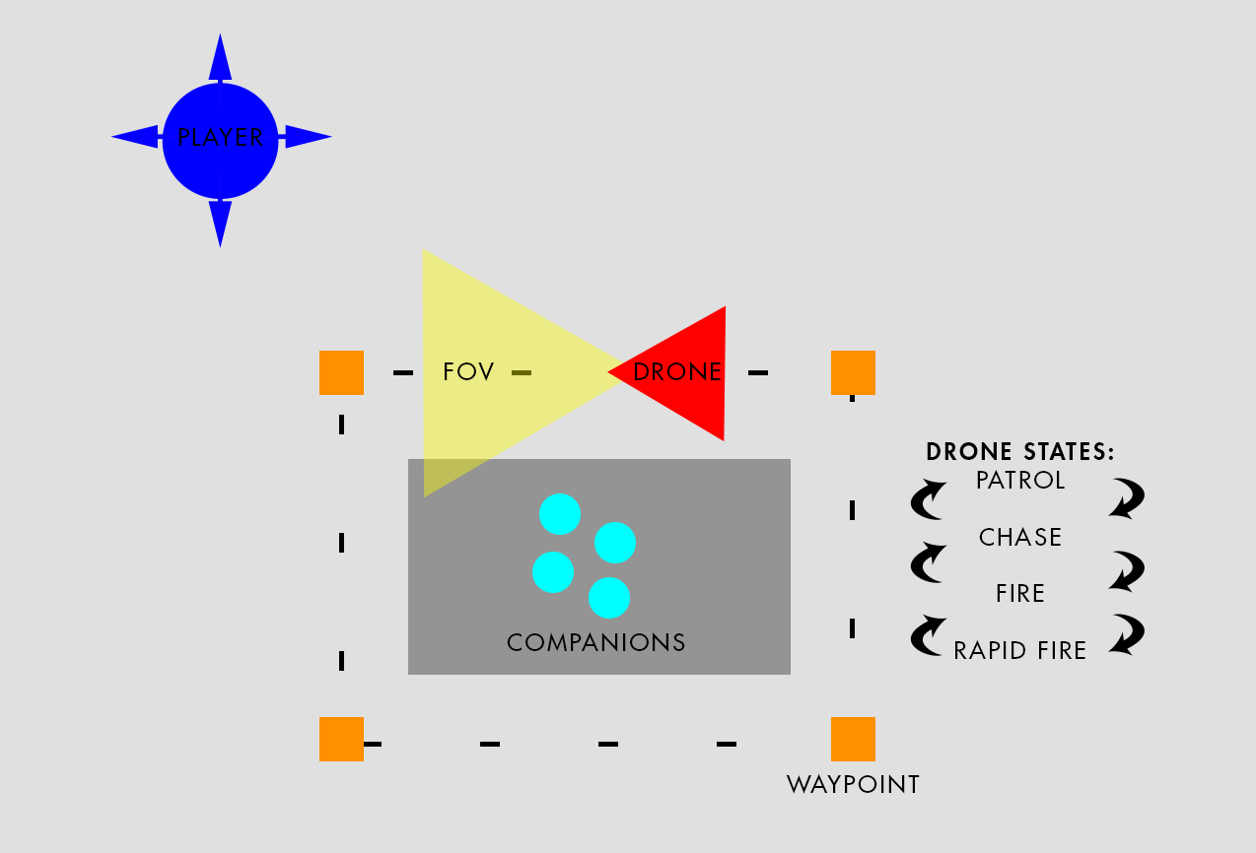
Figure 10. Schematic Game Setup

References
Crawford, C. (1982). The Art of Computer Game Design.
Bourg, D and Seemann, G. (2004) AI for Game Developers: Creating Intelligent Behavior in Games. O’Reilly Media, Inc.
Delloite. Artificial Intelligence. [S. l.], 2018. Available in: https://www2.deloitte.com/content/dam/Deloitte/nl/Documents/deloitte-analytics/deloitte-nl-data-analytics-artificial-intelligence-whitepaper-eng.pdf. Access: 17 mar. 2021.
Huizinga, Johan. (1949). Homo Ludens, Rowohlt, 23rd edition.
Mass, Laura E. Shummon Maass; Luc, Andy. Artificial Intelligence in Video Games. Available in: https://towardsdatascience.com/artificial-intelligence-in-video-games-3e2566d59c22. Acesse: 16 mar. 2021.
Millington, I and Funge, J. (2009). Artificial Intelligence for Games. Morgan Kaufmann Publishers. 2nd edition.
Munari, B. (1966). Design as Art. Penguin Group.
Rabin, S. (2013). Game AI Pro: Collected Wisdom of Game AI Professionals. A K Peters/CRC Press, 1st edition.
Rabin, S. (2015). Game AI Pro 2: Collected Wisdom of Game AI Professionals. A K Peters/CRC Press, 1st edition.
Reads, Smart. Inteligência Artificial: compreender em que consiste a I.A e o que implica a aprendizagem das máquinas. 1. Ed [S.I]: Smart Reads, p.14, 2017.
Russel, S and Norvig, P. (2010). Artificial Intelligence, A Modern Approach, Pearson Education, 3rd edition.
Scheel, J (2015). The Art of Game Design, A Book of Lenses. CRC Press, 2nd edition.

